
 
Sheri Berkeley
George Mason University
National Academies of Sciences, Engineering, and Medicine
Symposium on Assessing Hard-to-Measure Cognitive,
Intrapersonal and Interpersonal Competencies
Washington, DC; December 16, 2015
Thismaterialisbaseduponworksupporte
dbytheNationalScienceFoundation
underGrantNumber:DRL-1420448.Anyopini
ons,findings,andconclusionsor
recommendationsexpressedinthisma
terialarethoseoftheauthor(s)anddo
notnecessarilyreflecttheviewsoftheNationalScienceFoundation.

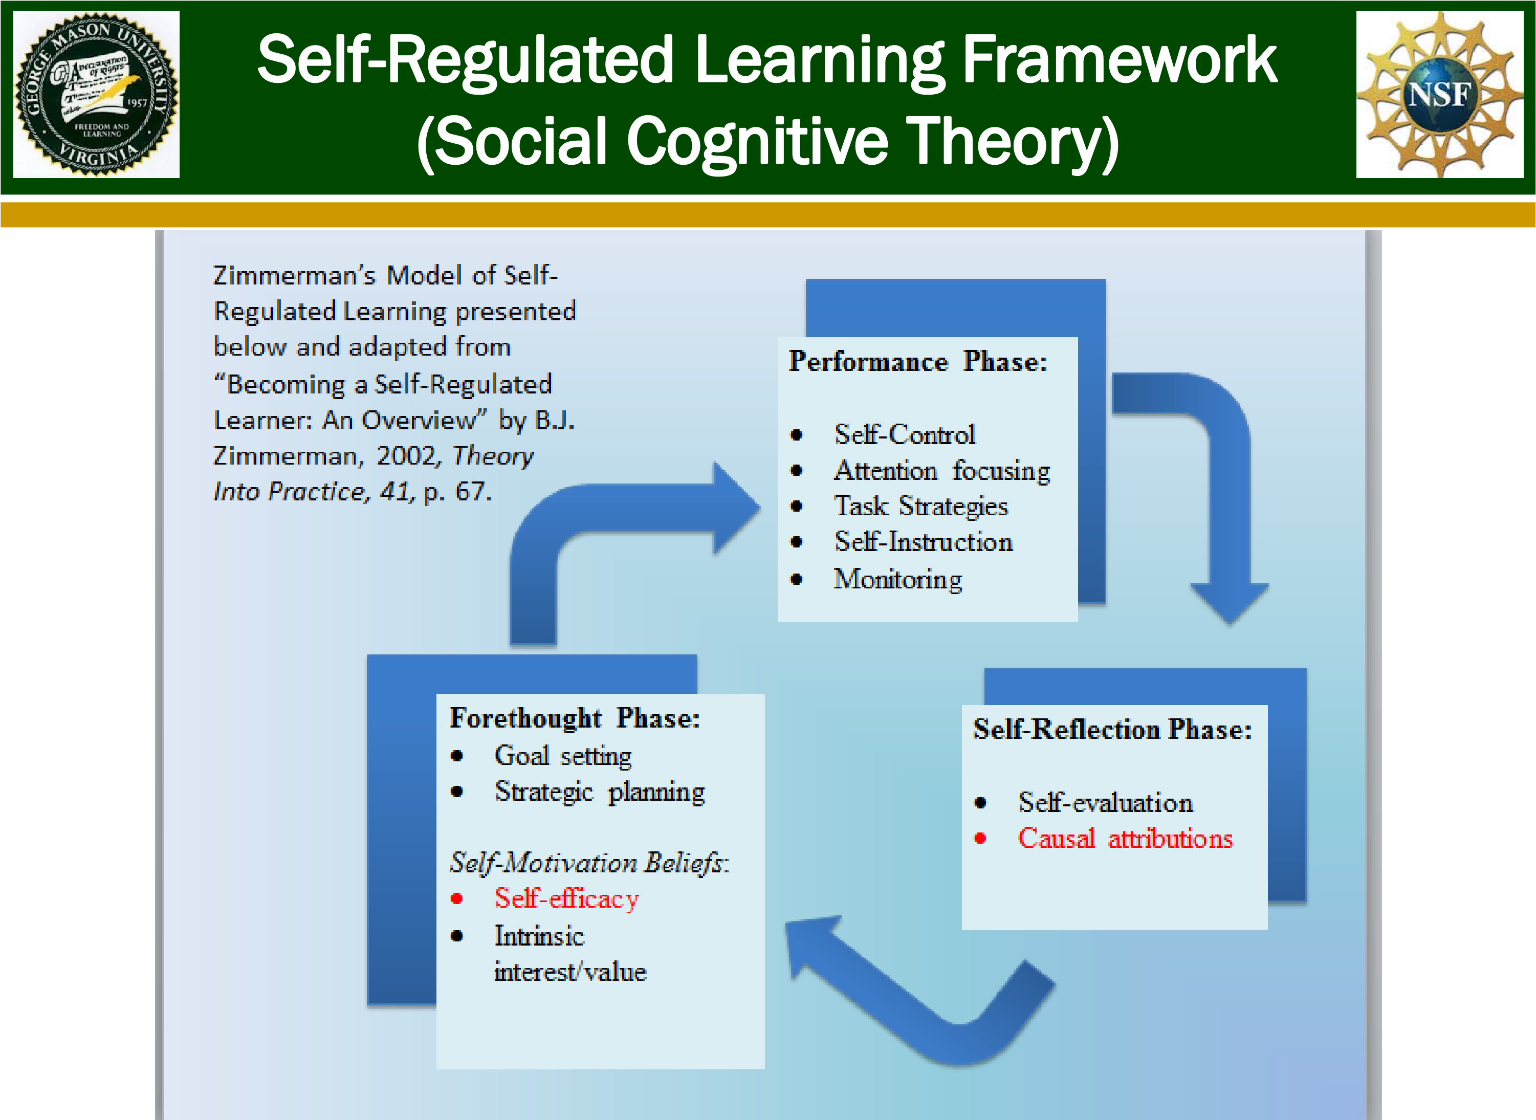


- Although highly capable, limited numbers of students with learning disabilities (LD) are pursuing careers in STEM fields, even though many work-related opportunities are available to these individuals (Basham & Marino, 2013).
- Because acquisition, retention, and demonstration of science knowledge can pose multiple challenges for students with LD, researchers have noted a critical need to foster students’ ability to self-regulate their own learning (e.g., Brigham, Scruggs, & Mastropieri, 2011).
- Students with LD are an ideal sample for this type of work precisely because
  - these students
characteristically display inappropriate causal attributions for learning
(e.g., Baird, Scott, Dearing,
Hamill, 2009; Tabassam &
Grainger, 2001), and o these attributions are malleable (e.g., Berkeley, Mastropieri, & Scruggs, 2011; Miranda, Villaescusa, & VidalAbarca, 1997).


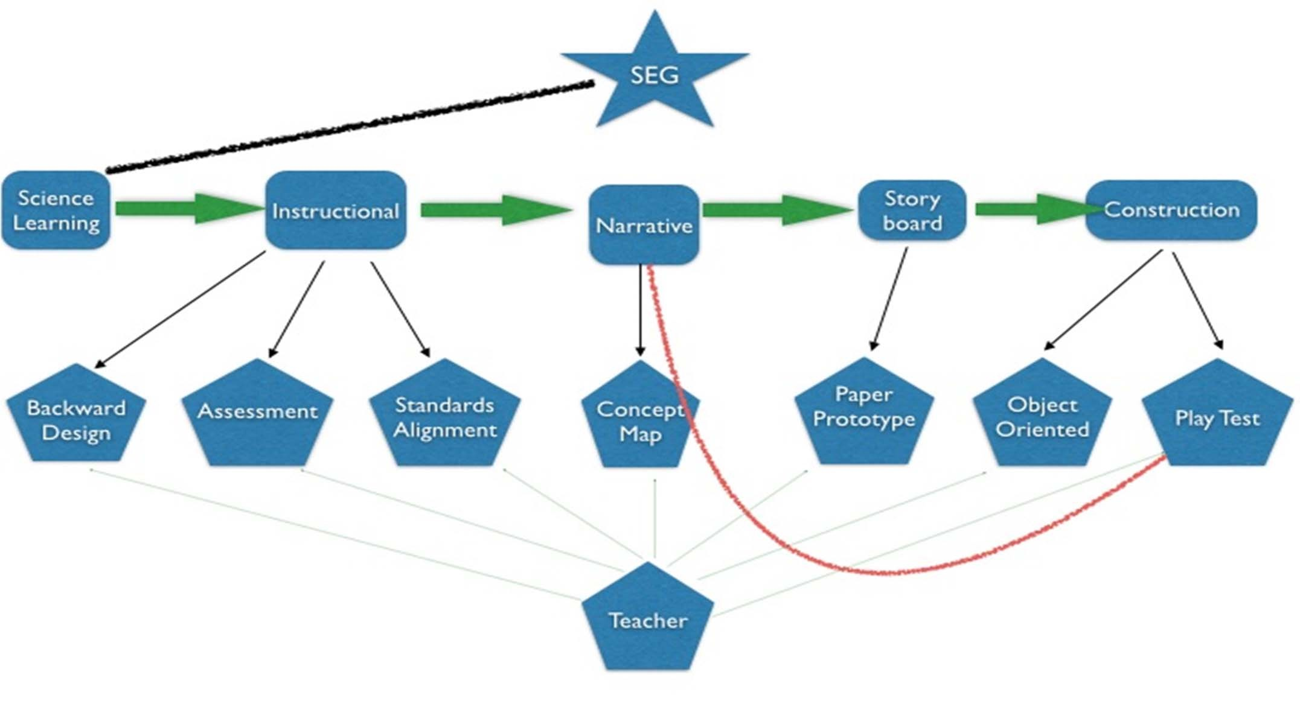
From: Annetta (2008)

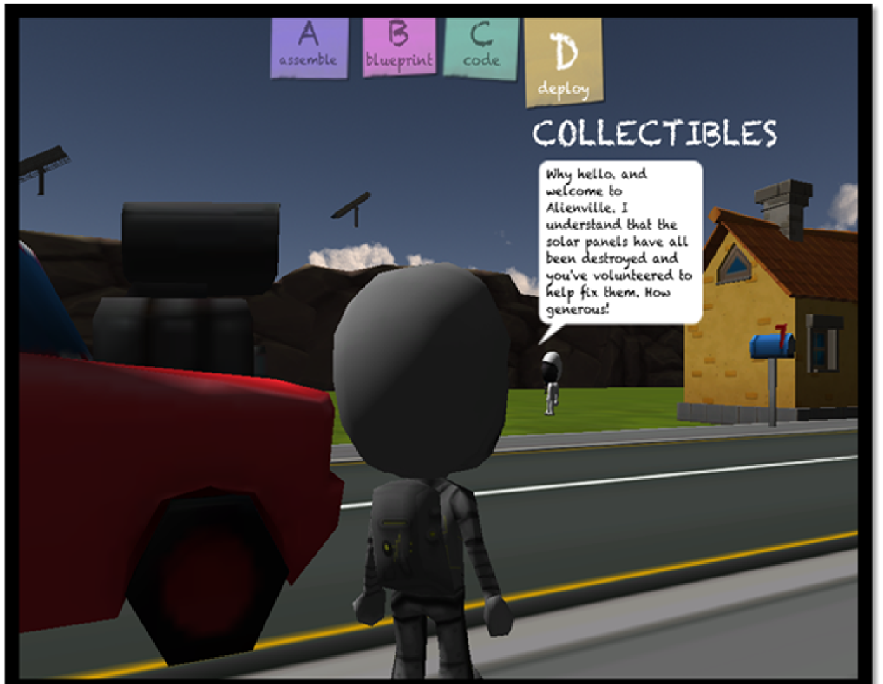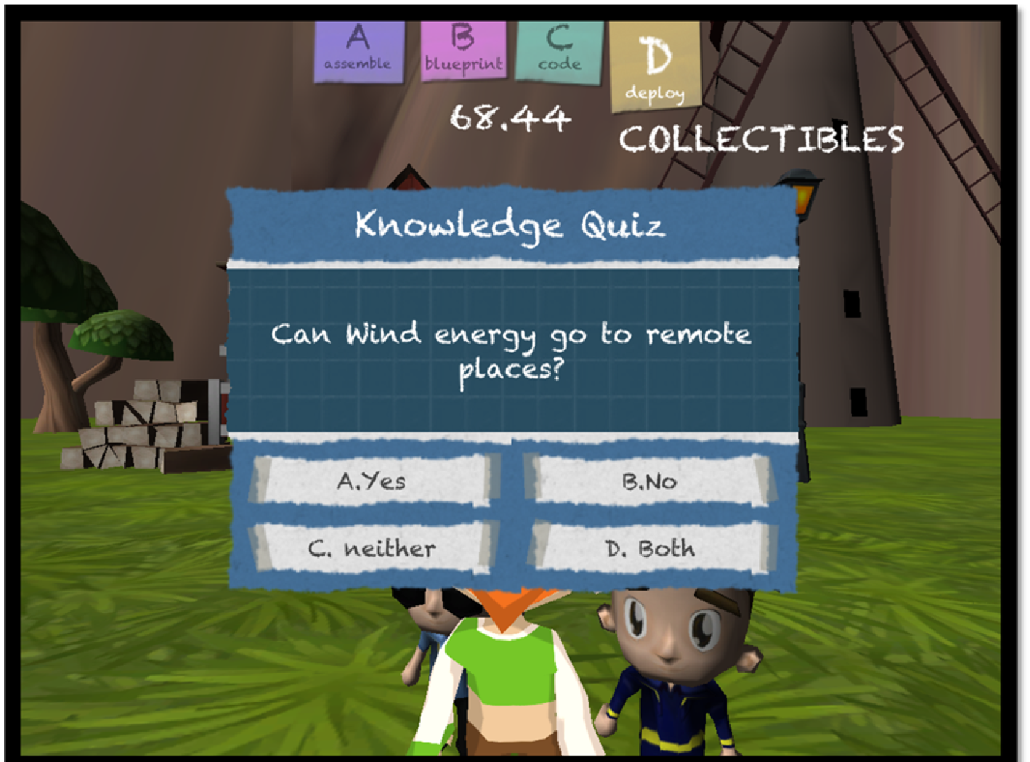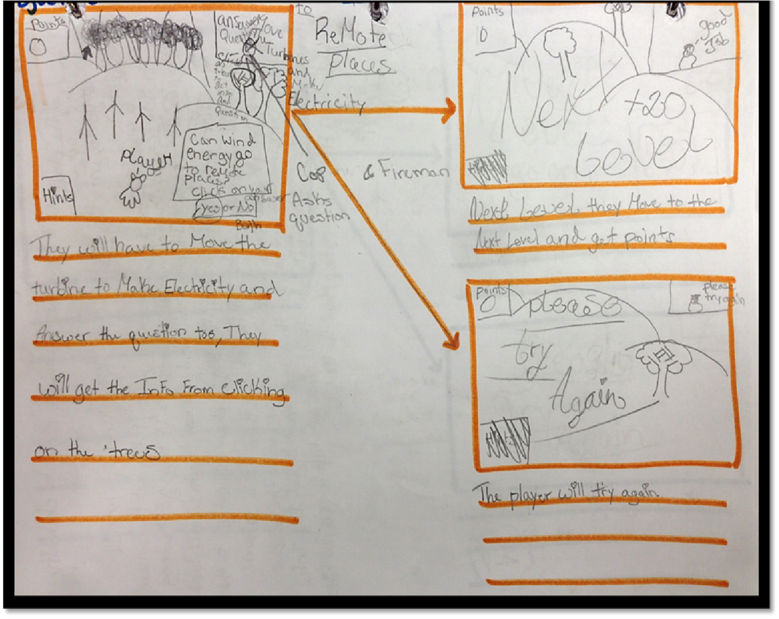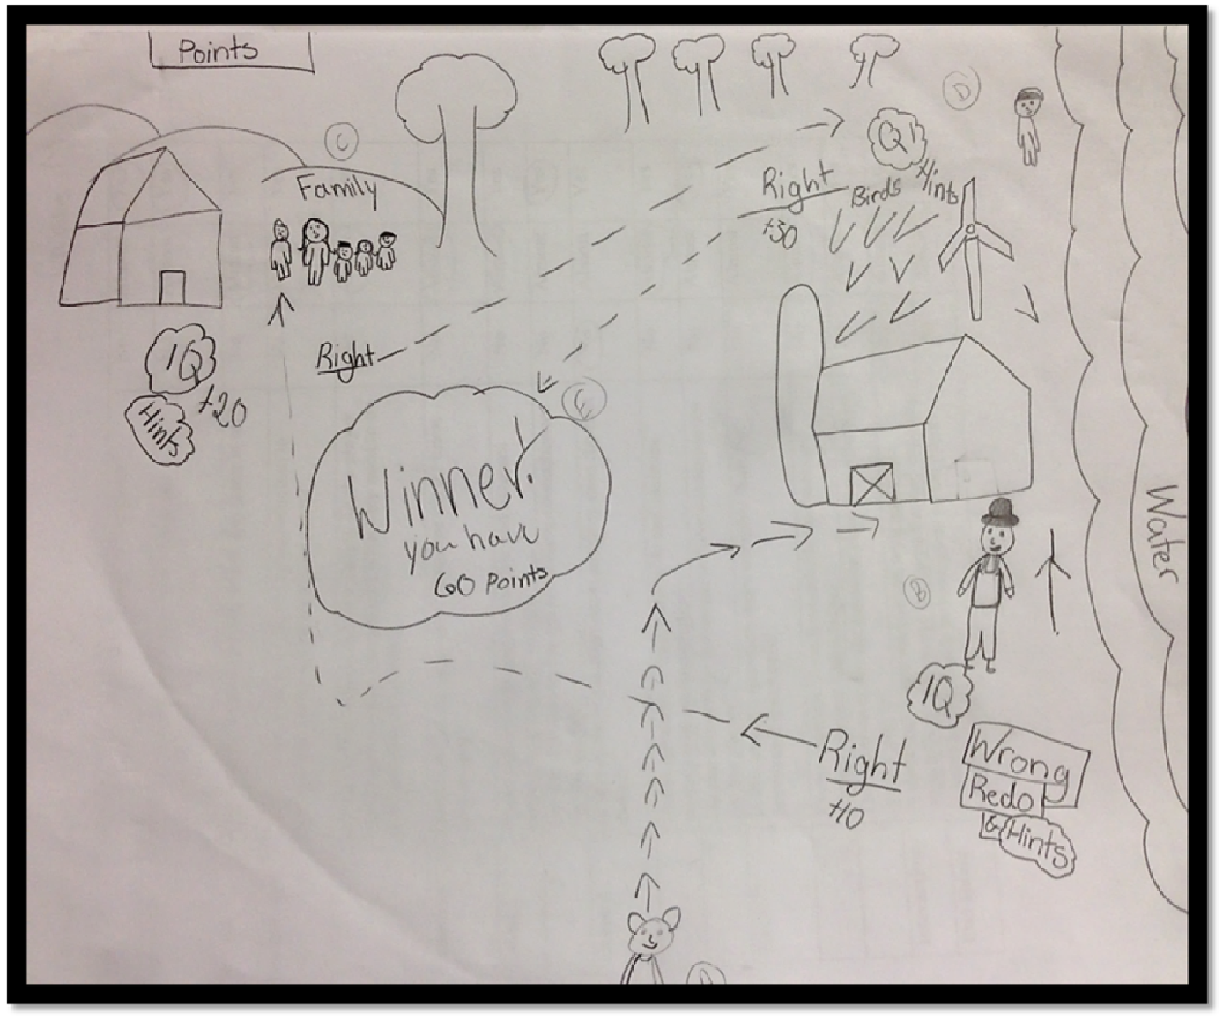


- Existing self-regulated learning (SRL) work primarily focuses on well-defined and/or discreet tasks, while less is known about the role of self-regulation in complex, long-term learning tasks (Schunk & Zimmerman, 2003; Bernacki, Nokes-Malach, & Aleven, 2015).
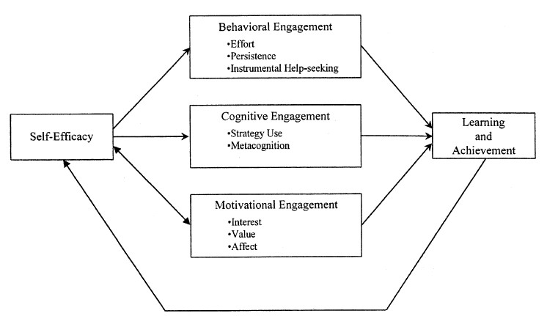
From: Linnenbrink & Pintrich (2003)
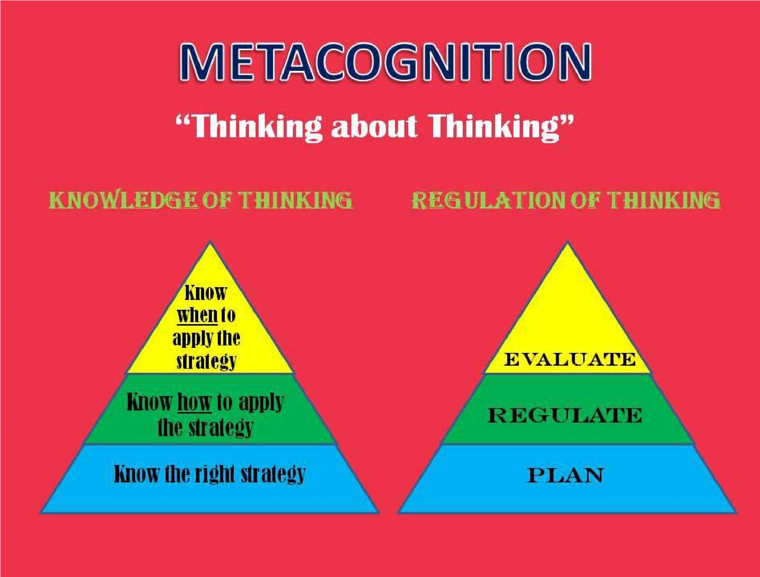
- Are we measuring selfregulation of science learning (rather than strategy use or some other cognitive behavior)?
- How do we measure self-regulation in a meaningful way?

  - When students are not reflective (or are not accurate in their reflections)?
  - Using data collection procedures that do not influence the self-regulation process?
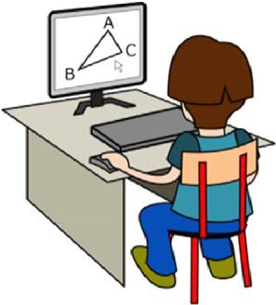

  - When goals and related tasks are complex and variable?
Sheri Berkeley sberkele@gmu.edu
Small group focus:
Self-regulation, motivational beliefs, and other factors affecting student learning and persistence in science and STEM

